12.Dez 2017

Important Note:
A)Please remove previous versions before installing a new version.
B)Installation path containing “SPACE” char's does not work.

What is LazToApk?
To build a piece of software which can be installed on an android device, you need Java JDK, Android SDK, Android NDK, ANT and laz4android.

LazToApk is a software which will help you to configure all these needed 3rd-Party Tools.

What's new?

See changes file .\changes.txt
Content
Step 01: Download&Install JDK 2
Step 02: Download&Install LazToApk 3
Step 03: Start&Configure LazToApk for the first time 5
Step 04: Start Lazarus and install packages. 6
Step 05: Install LAMW (Lazarus Android Module Wizard) 7
Step 06: Start SDK-Manager and install API's 8
Step 07: Restart LazToApk 10
Step 08: Build your first android app 10
Step 09: Run the app 11

Requirements

- Windows (I tested on WinXP and Win7)
- At least 6GByte free disk space.
- A quick internet connection, because 680MByte needs to be downloaded.
- Recommended: a real Android Device because the Android Emluator is very slow!

Note: The whole installation may take 30 minutes!

Setup the tools to create an Android App with Lazarus/Free Pascal

Please follow exactly this instructions, otherwise the chance is very high that your final app will not work!

I tested on windows xp sp3 and on windows 7.

Step 01: Download&Install JDK

Download latest Java JDK jdk-8uxxx-windows-i586.exe (32bit is important) from here: → Java JDK 8

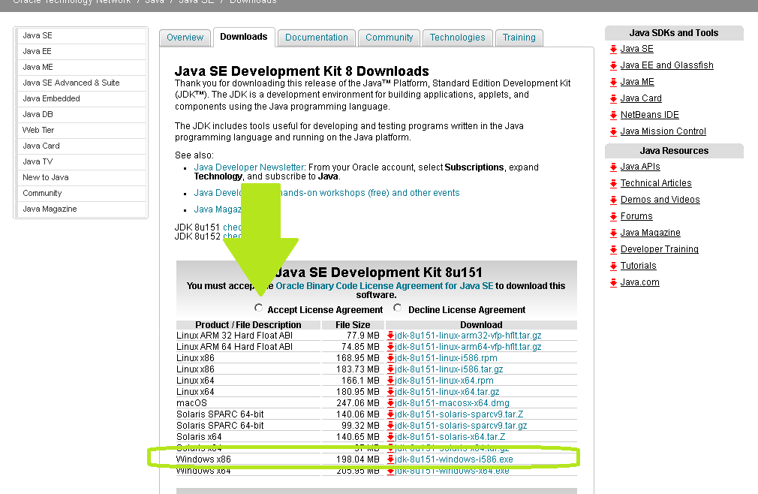

Run the downloaded installer.
It will be installed in to <C:\Program Files\Java\>.

Step 02: Download&Install LazToApk

LazToApk → Download the setup from here. (sourceforge.net)

Run the setup.

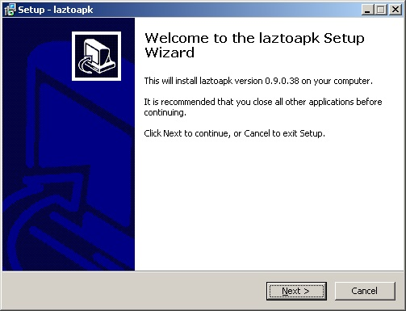 | 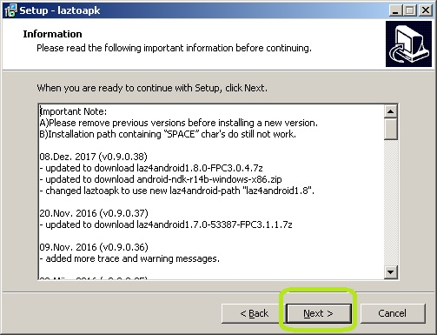
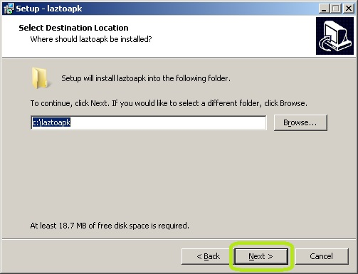 | 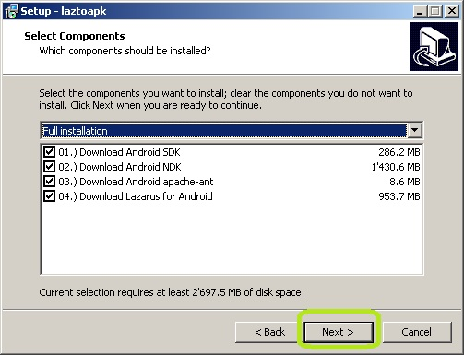
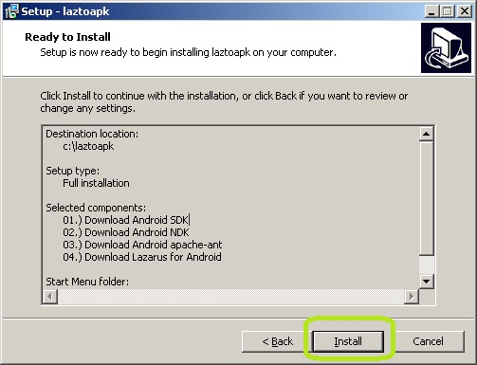 | 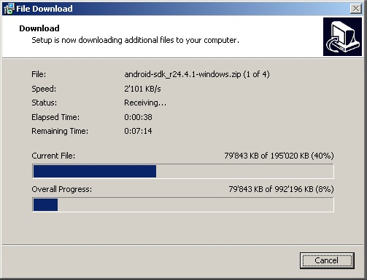

You can now go for a coffee! No user-action is required the next 20 minutes.
The download took on my machine about 16 Minutes. After the download, the files will be un-zipped automatically.

At the end of setup the batch-file <build.bat> gets automatically started.
→ laz4android get's compiled. This may take a while and look's something like this.

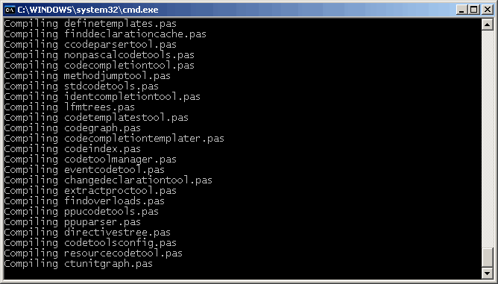

Step 03: Start&Configure LazToApk for the first time

The application <LazToApk> will be started.
LazToApk will verify if the folder's for JDK,SDK,NDK,ANT and the tool lazbuild.exe is available.
If everything went fine, it should look like this:
(If not, then a path setup dialog will show up and you must select the correct path manually.)

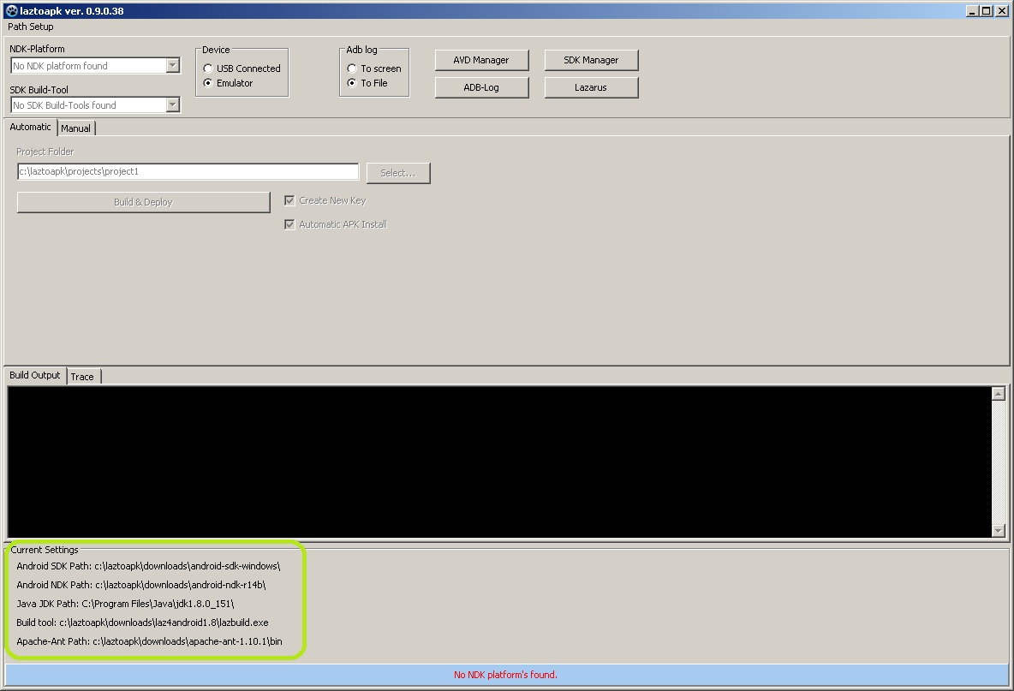

Step 04: Start Lazarus and install packages.
Start Lazarus by clicking onto Button <Lazarus>.
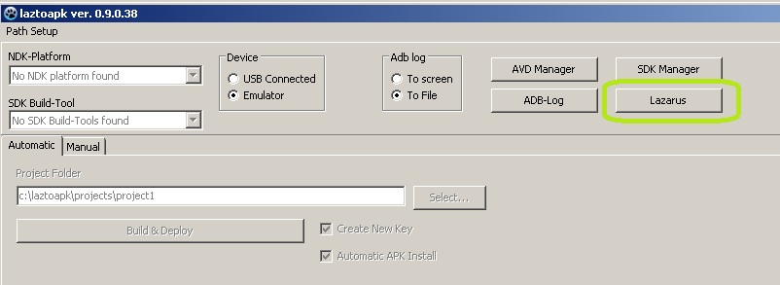
The Lazarus IDE should show up. Choose <Package>, <Install/Uninstall Packages>.
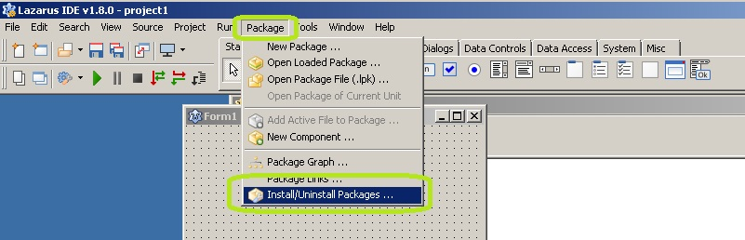

Select the package <CustomDrawn> and Press button <Install Selection>. | Select the package <OnlinePackageManager> and Press button <Install Selection>.
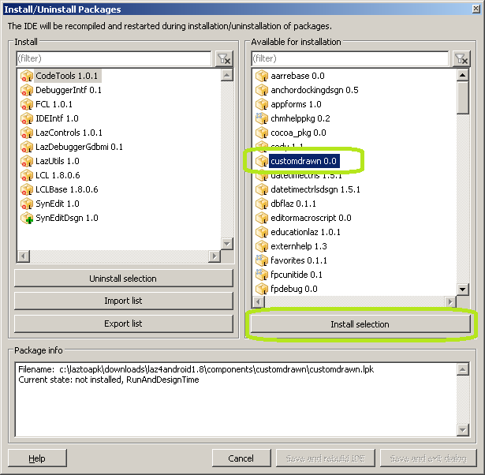 | 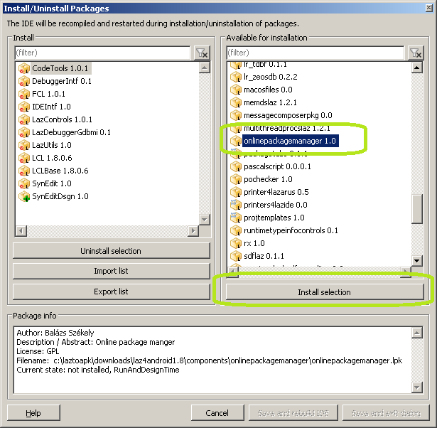

Press Button <Save and Rebuild IDE>
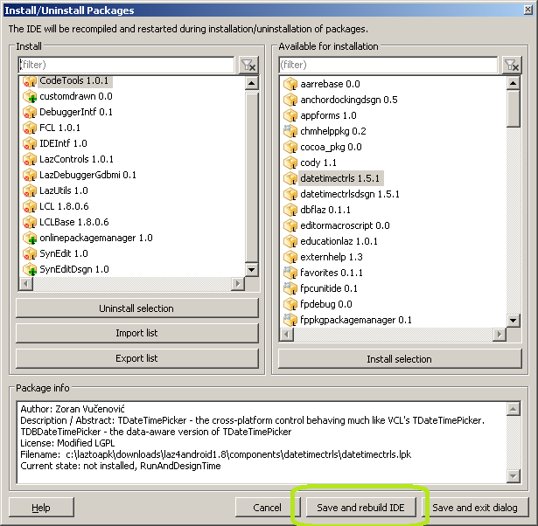
The Lazarus IDE gets rebuilt and restarted. This may take a while.

Step 05: Install LAMW (Lazarus Android Module Wizard)
Since the development of the CustomDrawn-Components seems to be “stalled”, I will try to move to LAMW. This move is not finished yet and will only happen with the help from the community.

Choose <Package> <Online Package Manager>
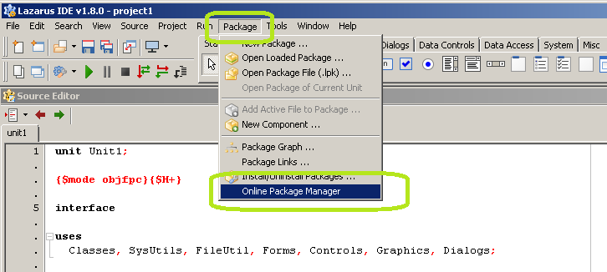
Select “LAMW” and press “install”.
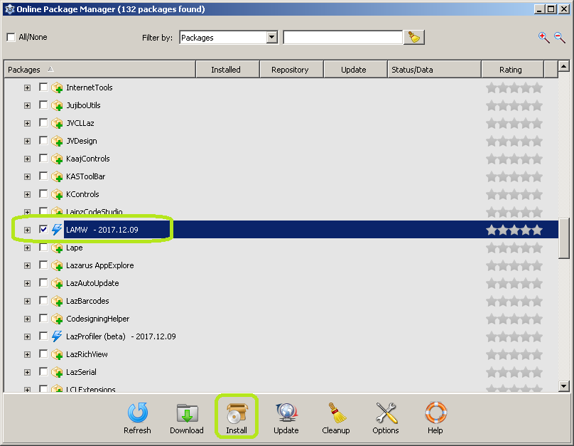
The package get’s downloaded and installed. After a while the following dialoge pops up. Press <Yes>.
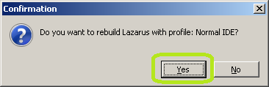
The Lazarus IDE gets rebuilt and should now have new component-tabs.
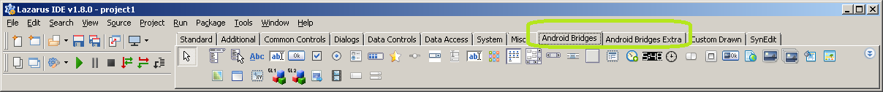

Step 06: Start SDK-Manager and install API's
Close Lazarus IDE.
Now LazToApk will look like this. It's time to start the <SDK Manager>.

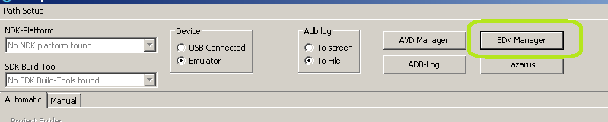
Select the following packages. (→ you can try some other's but I did not test with other version's!!!!)

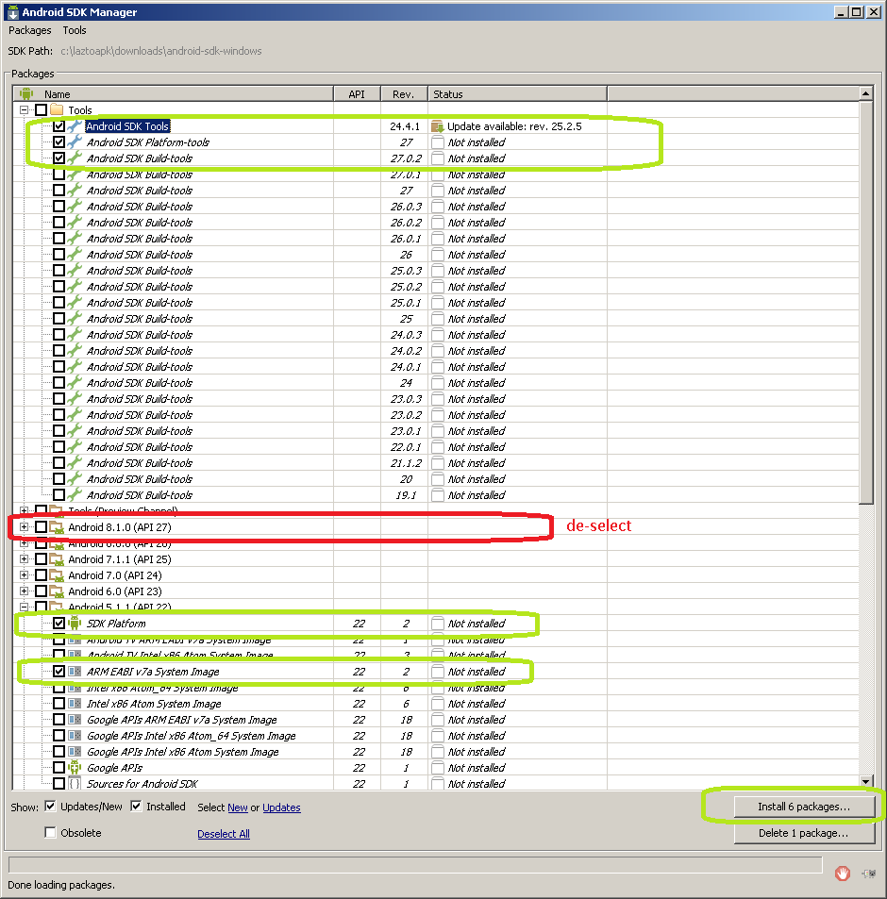
The following dialogs will show up.
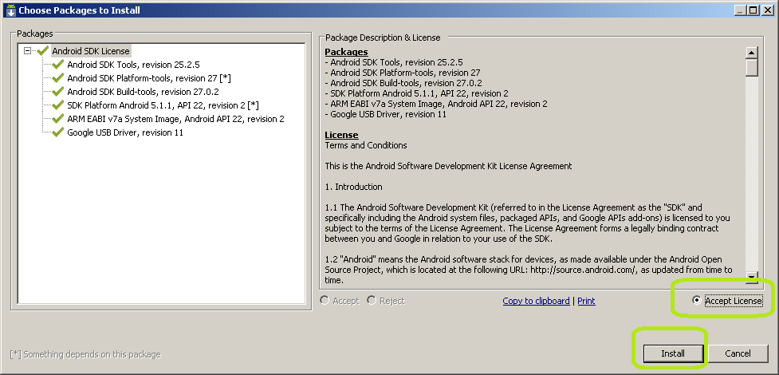  Accept Licence and press <Install>. | 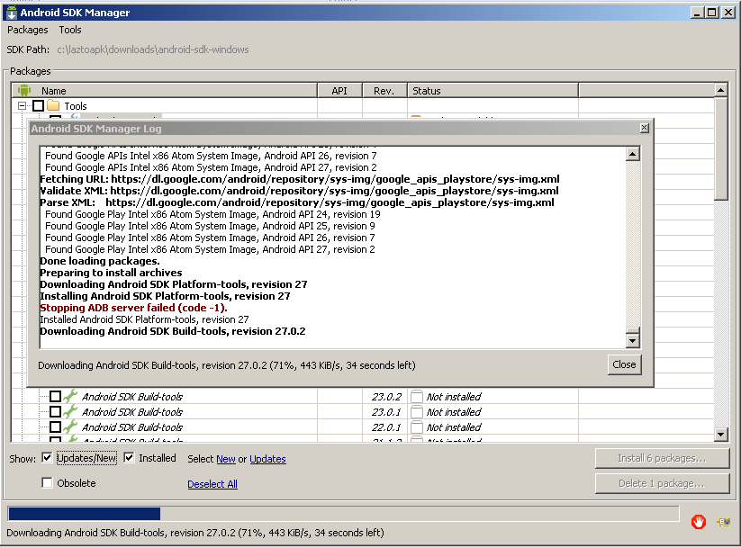  Just wait, this will take a some time...
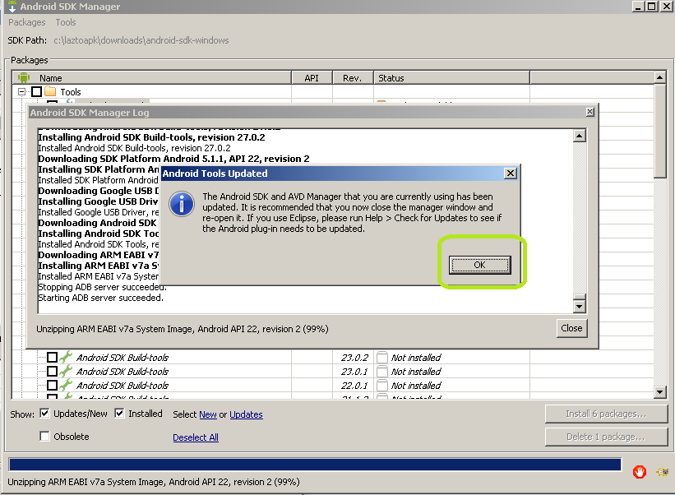  Press <OK> | 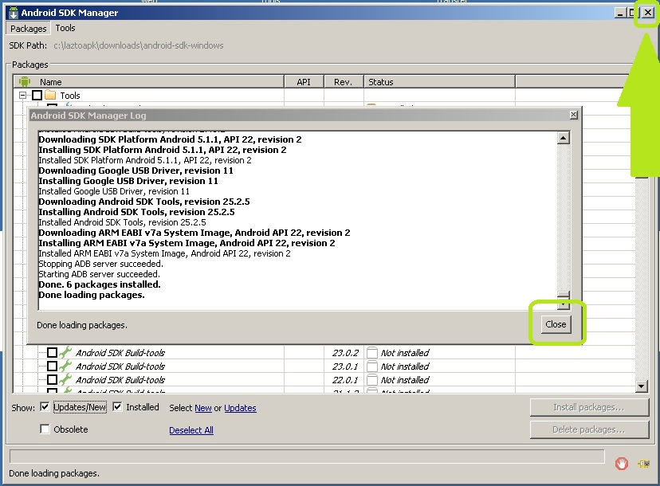  Now close the SDK Manager.

Step 07: Restart LazToApk

Close LazToApk.
Close the setup.
Start LazToApk again.
Connect your android device to the computer. (usb-connection)

Step 08: Build your first android app

Select <USB connected> and
press button „Build&Deploy“.
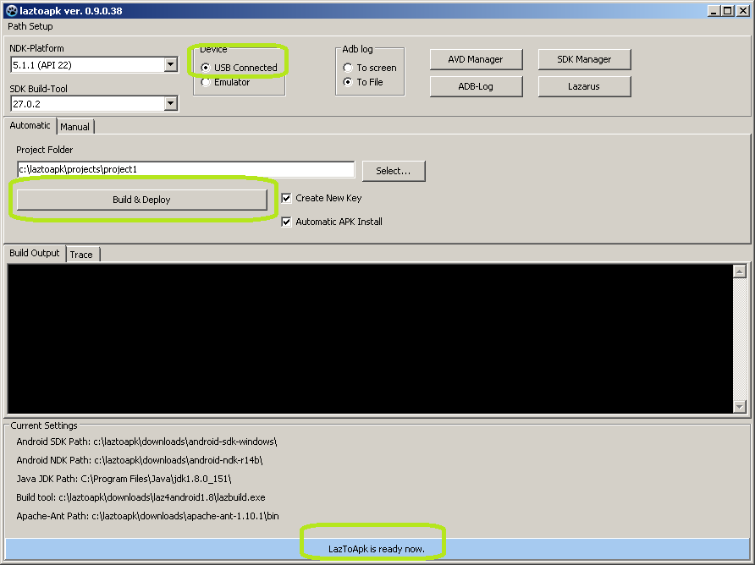
In the following dialog, define a password for your app and press button <OK>.

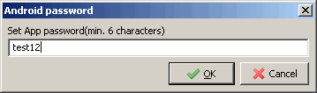
The following info message will appear.

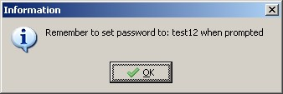

You have to enter the same password as before twice in the command windows

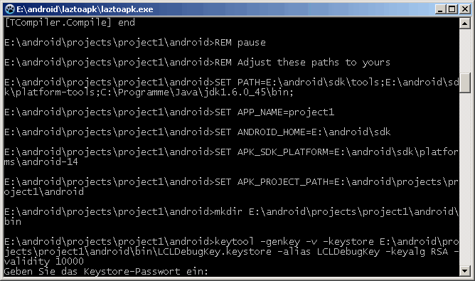
and do some more input as requested.
If everything works as expected, then it should look like this:
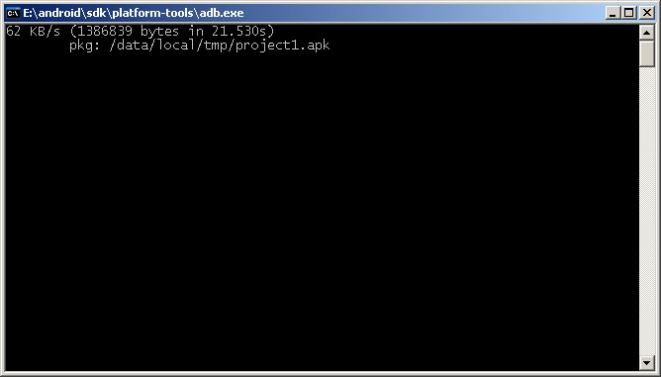

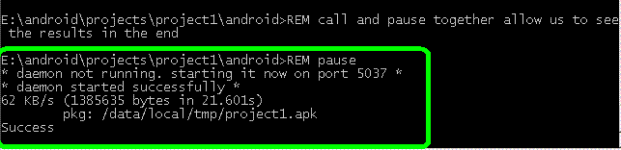
Well done, the app is now installed.

Step 09: Run the app
Let's run the app. Click onto the following icon:
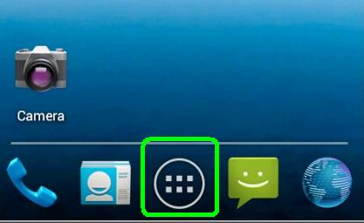
Then click on „Project1“.
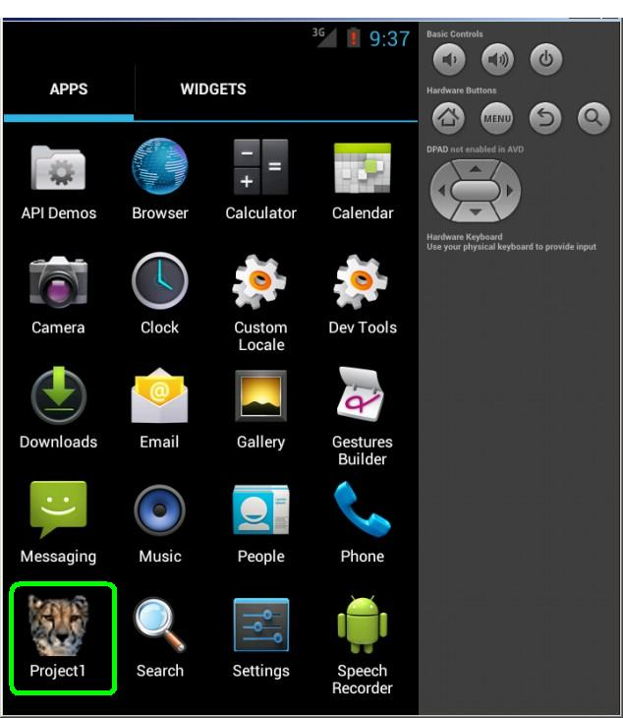
And enjoy your first android application.
